|  |  |
| --- | --- |
| Team ID | PNT2022TMID16931 |
| Project Name | Project – News Tracker Application |
| Maximum Marks | 8 Marks |

**Deployment of app in IBM cloud**

**Containerize the App**

In your project directory, create a file named "Dockerfile." *Suggestion: Name your file exactly "Dockerfile," nothing else.*

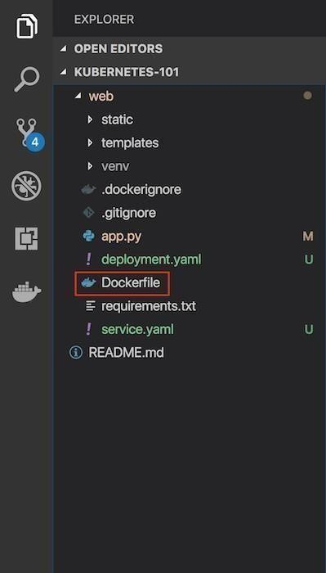

A "Dockerfile" is used to indicate to Docker a base image, the Docker settings you need, and a list of commands you would like to have executed to prepare and start your new container.

* In the file, paste this code:

|  |
| --- |
| FROM python:2.7  LABEL maintainer="Nithishkumar, krnithishkumar14@gmail.com" |

* RUN apt-get update
* RUN mkdir /app WORKDIR /app COPY . /app
* RUN pip install -r requirements.txt
* EXPOSE 5000
* ENTRYPOINT [ "python" ]
* CMD [ "app.py" ]

Show more

## Explanation and breakdown of the above Dockerfile code

|  |
| --- |
| FROM python:2.7 |

1. The

first part of the code above is:

2.

Because this Flask application uses Python 2.7, we want an environment that supports it and already has it installed. Fortunately, DockerHub has an official image that's installed on top of Ubuntu. In one line, we will have a base Ubuntu image with Python 2.7, virtualenv, and pip. Thereare tons of images on DockerHub, but if you would like to start off with a fresh Ubuntu image andbuild on top of it, you could do that.

1. Let's look at the next part of the code:
2. LABEL maintainer="Nithishkuamar,krnithishkumar14@gmail.com"
3. RUN apt-get update

1. Note the maintainer and update the Ubuntu package index. The command is RUN, which is a function that runs the command after it.

|  |  |
| --- | --- |
| 7. | RUN mkdir /app |
| 8. | WORKDIR /app |
| 9. | COPY . /app |

1. Now it's time to add the Flask application to the image. For simplicity, copy the application under the /app directory on our Docker Image.

WORKDIR is essentially a **cd** in bash, and COPY copies a certain directory to the provided directory in an image. ADD is another command that does the same thing as COPY, but it also allows you to add a repository from a URL. Thus, if you want to clone your git repository instead of copying it from your local repository (for staging and production purposes), you can use that. COPY, however, should be used most of the time unless you have a URL.

1. Now that we have our repository copied to the image, we will install all of our dependencies, which is defined in the requirements.txt part of the code.

|  |
| --- |
| RUN pip install --no-cache-dir -r requirements.txt |

12.

13.

|  |
| --- |
| EXPOSE 5000 |

We

want to expose the port(5000) the Flask application runs on, so we use EXPOSE.

14.

1. ENTRYPOINT specifies the entrypoint of your application.
2. ENTRYPOINT [ "python" ]
3. CMD [ "app.py" ]

# Build an image from the Dockerfile

Open the terminal and type this command to build an image from your Dockerfile: docker build -t <image_name>:<tag> .(note the period to indicate we're in our apps top level directory). For example: docker build -t app:latest .

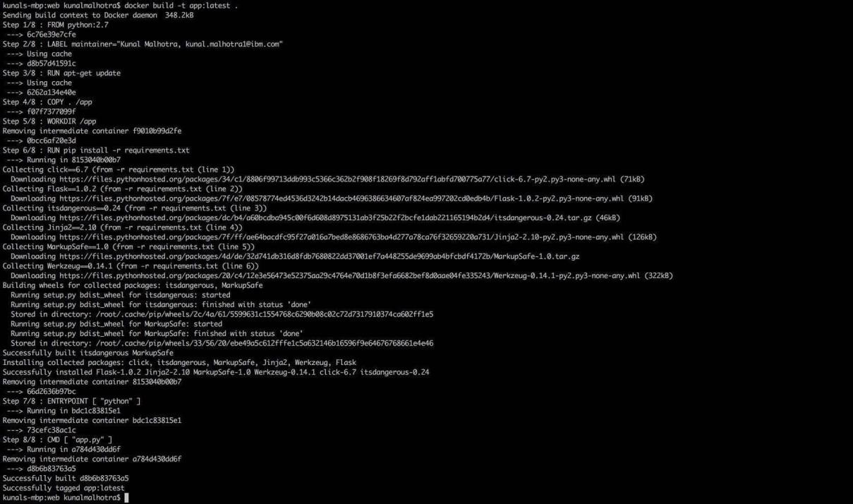

# Run your container locally and test

After you build your image succesfully, type: docker run -d -p 5000:5000 app

This command will create a container that contains all the application code anddependencies from the image and runs it locally.



